Charis Gee, Cathey Seo, Rachel Lee, Else Protzko
period 6

Macromolecule Matrix Poster

Macromolecule | Definition | Function | Examples | Draw Structure
Nucleic Acids  Monomer: nucleotides | Nucleic Acids are a group of long, linear macromolecules that carry genetic information directing all cellular functions. Each chain contains repeating chains of nucleotides, which consist of a nitrogen base attached to a sugar phosphate. The two main nucleic acids are DNA and RNA. | Their function is to allow organisms to transfer genetic information from one generation to the next. | 1. DNA  -deoxyribonucleic acid  -contains the biological and genetic instructions that control the day-to-day functions of cells  -each molecule of DNA is a double helix formed from two complementary strands of nucleotides held together by hydrogen bonds  -DNA stored in nucleus in eukaryotes  2. RNA  - It is also known as Ribonucleic acid.  -The functions of the RNA is to send instructions from the DNA for the synthesis of proteins, to act as a couplet between the genetic code and the building blocks of protein, and become a structural part of ribosomes.  -The RNA consists of the mRNA, rRNA, and tRNA.  -Each RNA molecule is typically a single strand, consisting of a short chain of nucleotides.  -RNA can be shaped like a helix  3. mRNA  -It is also known as the messenger RNA.  - The function of the mRNA is to transport information from the DNA to the ribosome.  - The coding sequence of the mRNA designates the amino acid sequence of the protein that is created.  -In prokaryotes, mRNAs contain an exact copy of the original DNA sequence.  -In eukaryotes, mRNA molecules are made up of small segments of the original gene.  4. tRNA  -It is also known as the transfer RNA.  -The function of the tRNA is to act as the link between the nucleotide squence of the nucleic acids: DNA and RNA and the amino acid sequence of proteins.  -There is at least one tRNA for each of the twenty naturally occurring amino acids.  -Each tRNA is characterized by a specific three-nucleotide sequence in one region and its ability to link with an amino acid. | 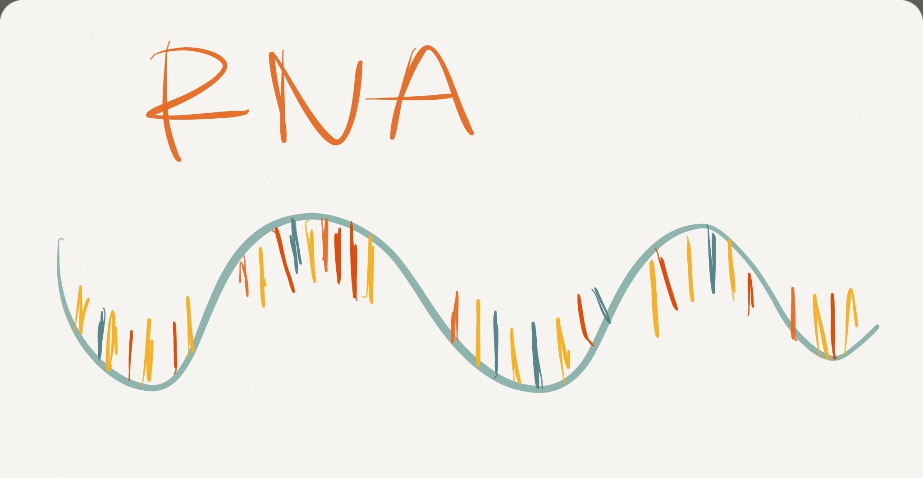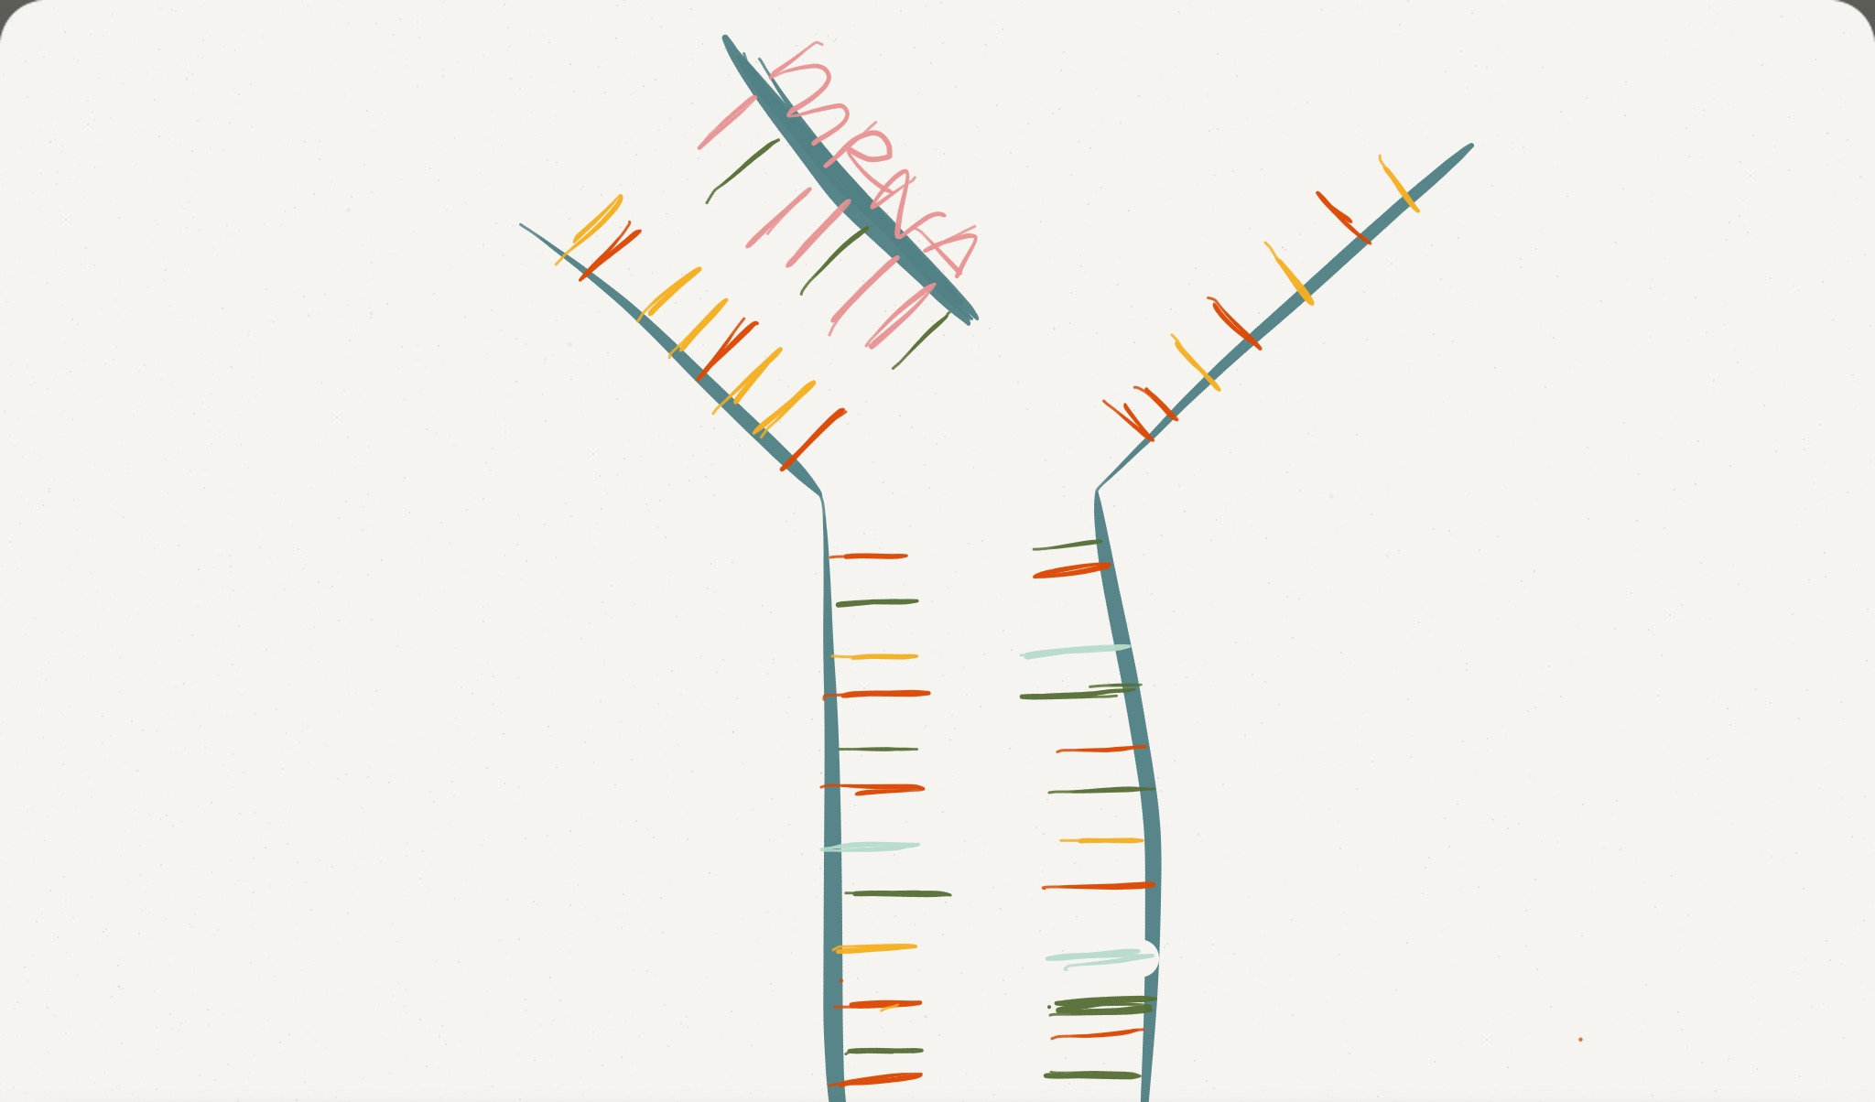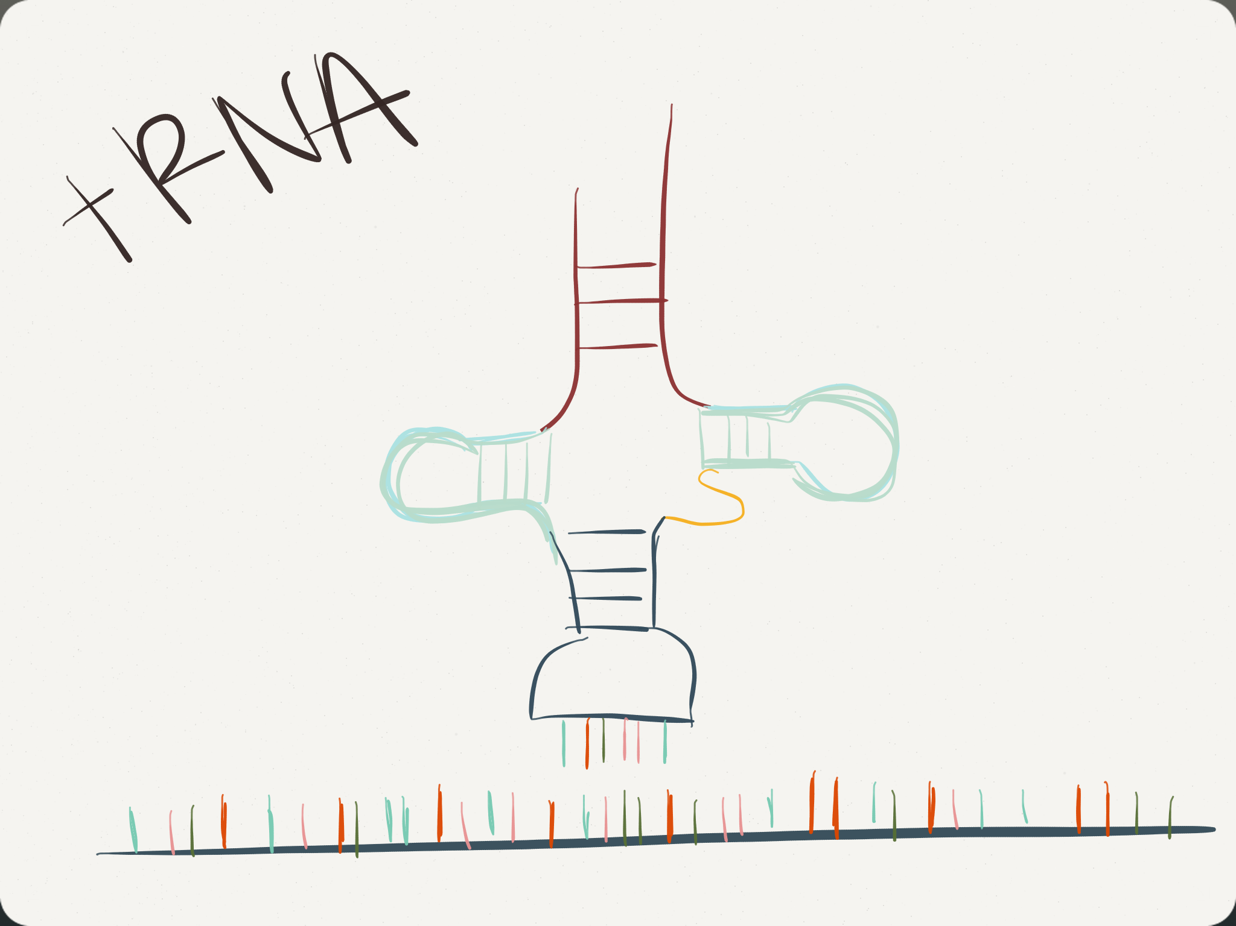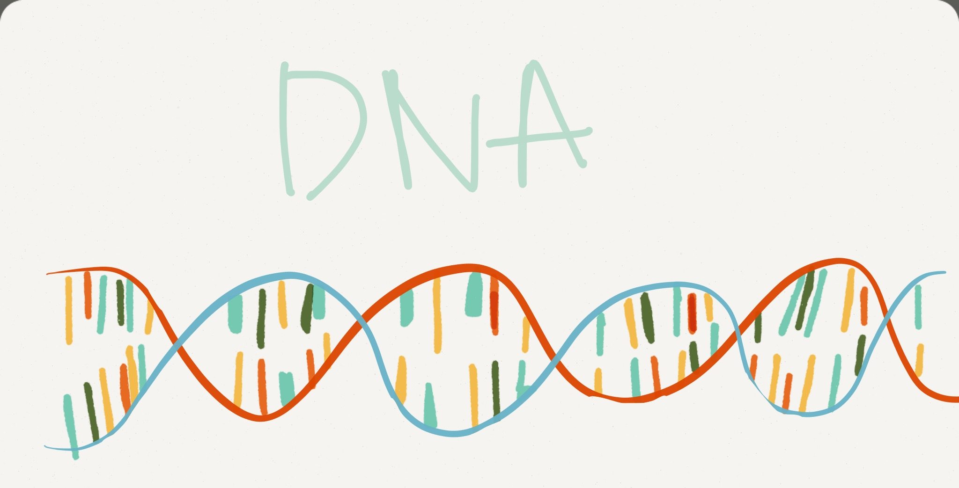

Macromolecule: Macro-questions!

1. A macromolecule is a big molecule made of smaller molecules and atoms. How do smaller molecules make up larger molecules? What keeps them together? How do they fit together? Macromolecules are formed by dehydration synthesis. Macromolecules are made by monomers. The monomers create covalent bonds which form polymers. Monomers release water molecules known as byproducts.

2. The four primary macromolecules of life work together in living organisms just like cells do. How do you think these molecules would work together to complete a function in the human body? For example, how are carbohydrates, lipids, and proteins related to metabolism? Homeostasis? Carbohydrates are related to metabolism because they contain sugars called polysaccharides, disaccharides and monosaccharides which are metabolized into glucose. Glucose is the only sugar our body uses for energy. Glucose is also used to maintain homeostasis because our bodies use energy to keep internal temperatures. Lipids are related to metabolism and homeostasis because lipids are involved in fatty acid oxidation which produces the synthesis of lipids called lipogenesis. The cell membrane is a lipid bilayer that prevents that passage of water and ions. This allows cells to maintain a higher concentration of sodium ions out the outside of the cell. This helps the cell maintain homeostasis. Proteins have structural or mechanical functions, such as actin and myosin in muscle and the proteins in the cytoskeleton, which form a system of scaffolding that maintains cell shape. Other proteins are important in cell signaling, immune responses, cell adhesion, and the cell cycle. Proteins are also necessary in animals' diets, since animals cannot synthesize all the amino acids they need and must obtain essential amino acids from food. Through the process of digestion, animals break down ingested protein into free amino acids that are then used in metabolism.

3. Every molecule and macromolecule has a unique shape. Some are long like lipids; others are huge and branch in every direction like proteins. How does the shape of a macromolecule relate to its function? Most macromolecules acquire their function by interacting with other macromolecules. They work similar to locks and keys. Without the right fit, the molecule can not interact with its intended target, and loses its function.

4. How and why are the shapes of the macromolecules determined?

Macromolecules are polymers, which are long chains of subunits called monomers. The shapes of macromolecules are determined because the shape determines the function of each macromolecule, so knowing the shape of a macromolecule allows one to also find the function. Some ways in which the shape of a macromolecule can be determined is through mono-modality and polymodality, or finding the average of the molecular weights.

Protein: 3-D
Carbohydrate: ch20
lipids: fatty acid

