PROTEINS
General Information
Drawing:
Definition:
Function: To support parts of the cell, to catalyze reactions (enzymes), to transport materials
Monomer: an amino acid
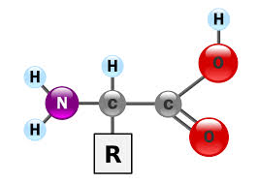

Actin - William Choi
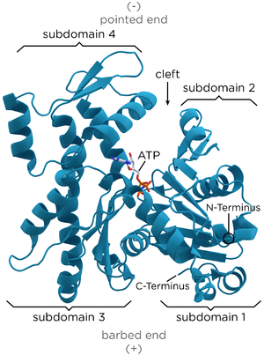
https://en.wikipedia.org/wiki/Actin
http://www.ncbi.nlm.nih.gov/pubmed/21314430
Actin: Actin, the most profuse of proteins, is essential to the body.
Function: Actin primarily performs as contraction agent of the muscles in the body. Actin possesses two forms: g and f. Muscle contraction occurs through the use of actin because the actin switches forms to pull the muscle back. Also, actin performs as a shaping and structure agent for the cell (mostly eukaryotic). This also applies to the cell in that it controls the polarity of the cell at a certain area.

Amylase - Abigail Lidar
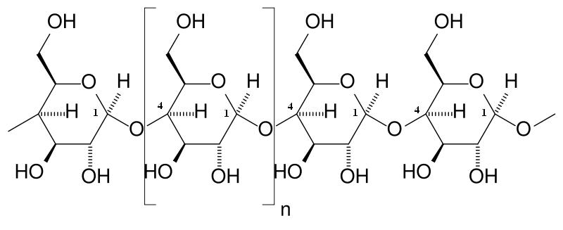
Definition: enzyme found mainly in saliva and pancreatic fluid
*note: salivary and pancreatic amylase are examples of alpha amylase; there also exists
beta and gamma amylase
Function: catalyzes the hydrolysis (chemical breakdown due to a reaction with water) of carbohydrates into disaccharides, and then monosaccharides such as glucose
Monomer: amino acid

Example: glucoamylase
- type of digestive enzyme that breaks down starch (especially starch that occurs naturally in vegetables) by cleaving a free glucose molecule from the end of a sugar-based chain (as opposed to breaking the chains into smaller ones)
- Interesting facts:
  - Although glucoamylase is most often produced in the mouth and pancreas, it can also be taken from non-animal sources.
  - When combined with other enzymes, glucoamylase has been proven to ease the effects of irritable bowel syndrome, gastrointestinal issues, some autoimmune disorders, and even food allergies.

Pepsin - Christian Soon Kim
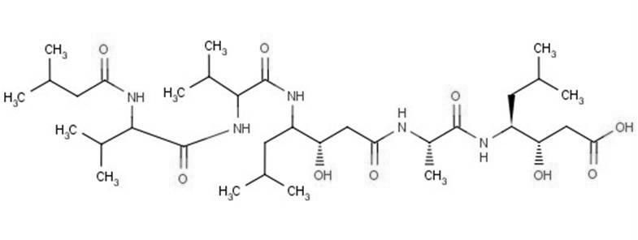
http://info.agscientific.com/blog/bid/131564/Exploring-the-uses-of-pepstatin-A

Definition: Pepsin is one of three proteolytic enzymes in the stomach. The other two proteolytic enzymes are chymotrypsin and trypsin.

Function: Pepsin is an enzyme whose zymogen is released by cells in the stomach that degrade protein in peptides. In the presence of hydrochloric acid, pepsin splits proteins into proteoses and peptones. With the help of pepsin, the substance is broken down into simpler molecules that the intestinal lining can easily break down.
Monomer: chymotrypsin
Example: pepsin C (gastricsin)
- Gastricsin is a digestive enzyme that is produced in the stomach.
- Gastricsin makes up a majority of the gastric mucosa. This “mucus” lines the inner walls of the intestine and help in the breakdown of essential proteins.

Keratin- Ethan Co
see the presentation

Drawing of chemical structure:
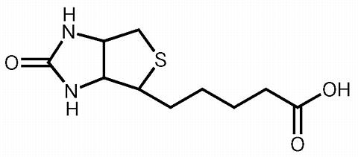
Example squares:
- Name of example molecule: Keratin
- Function of example molecule: Structural protein strengthening fibers; strengthens fingernails, hair, muscles, and even organs
- Interesting facts about the example

Collagen - Phillip Lee
https://patentimages.storage.googleapis.com/EP1354894A2/00040001.png
phillipp wats a monomer of pepsin???????? Sincerely, Christian Kim
im not sure cuz it says that pepsin is an enzyme; i think it is a monomer in and of itself.

Definition: Collagen is the main structural protein tends to be found in the connective tissue of animals.

Function: Collagen acts as a “glue” for animal bodies as it supports muscles, bone structure, tendons, ligaments, etc.

Monomer: Tropocollagen: a subunit for making collagen chains

Example:

Lysozyme- Sarah
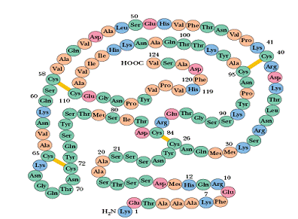
Chemical structure
Definition- Antimicrobial enzyme in many bodily fluids of animals, i.e. egg whites, blood, tears, milk, and saliva.
Function- It kills bacteria by breaking down a part of the cell wall. The large groove in the protein binds to chitodextrins (carbohydrates) in the cell wall, causing the bonds between the saccharides to break, and it then catalyzes the hydrolysis of these molecules.
Monomer- An amino acid

Bibliography
- http://www.globalhealingcenter.com/natural-health/glucoamylase/
- http://www.enzymeessentials.com/HTML/amylase.html
- http://science.marshall.edu/murraye/images/amylose.JPG

