Protein Structure
POGIL™ Activities for AP* Biology
What are the levels of protein structure and what role do functional groups play?
Why?
Proteins accomplish many cellular tasks such as facilitating chemical reactions, providing structure, and carrying information from one cell to another. How a protein chain coils up and folds determines its three-dimensional shape. Its shape will, in turn, determine how it interacts with other molecules and thus performs its function in the cell.
Model 1 – Formation of a Peptide Bond
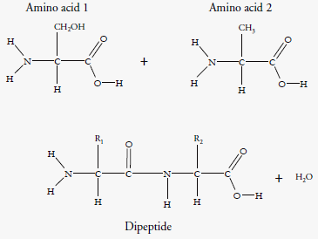
1. Examine the amino acids in Model 1.
a. Circle an amine group in the diagram.
b. Draw a triangle around a carboxylic acid (carboxyl) group.
2. How are the amino acids similar to one another?

3. How are the amino acids different from one another?

4. How many amino acids are involved in the reaction to make a dipeptide?

5. In Model 1 the original amino acids are combined through a condensation reaction to make the dipeptide.
a. What does R1 represent in the dipeptide?

b. What does R2 represent in the dipeptide?

6. Put a box around the atoms in the amino acids that become the H2O molecule produced by the reaction in Model 1.
7. A peptide bond is a covalent bond linking two amino acids together in a peptide.
a. Circle the peptide bond in Model 1.
b. Between which two atoms in the dipeptide is the peptide bond located?

c. Between what two functional groups is the peptide bond located?

8. There are 22 different amino acids found in nature. Two were shown in Model 1. Additional examples are shown below. With your group, write one or two grammatically correct sentences to describe how these amino acids are similar and how they are different. Use the terms R-group, amine group, and carboxyl group in your description.
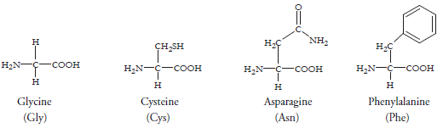

Model 2 – Protein Structure (Part A)
Primary Structure
Amino acid sequence: Ser – Tyr – Ala – Phe – Val – Cys – Tyr – Asp – Cys – Gly
Peptide structure:
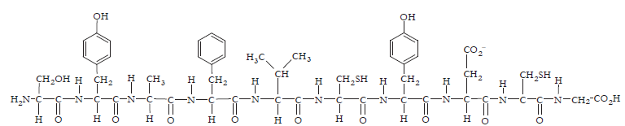
Secondary Structure
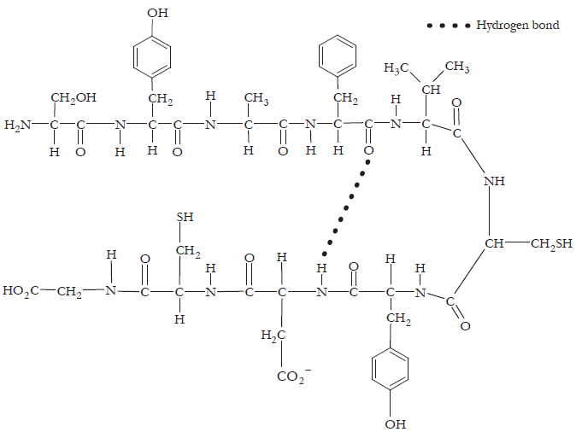
9. Locate the primary structure of the polypeptide in Model 2.
a. Draw an arrow to two different peptide bonds in the diagram.

b. Circle three separate amino acids that were joined together to make the polypeptide.

10. The first five amino acids in this polypeptide are serine, tyrosine, alanine, phenylalanine, and valine, in that order (Ser-Tyr-Ala-Phe-Val). If the amino acids were changed or rearranged (i.e., to Val-Phe-Ala-Ser-Tyr), the polypeptide would have a different name and identity. With your group, use this information to write a definition of the primary structure of a protein.

11. Locate the secondary protein structure in Model 2.
a. What types of bonds are holding the secondary structure in place?

b. What groups on the amino acids are always involved in these bonds?

12. Draw a rectangle around two different R groups on the amino acids in the secondary structure in Model 2.

13. Is there any interaction between R groups in the secondary structure in Model 2?

14. Secondary protein structure can take the form of an alpha(α)-helix or a beta(β)-pleated sheet, as illustrated below.
a. Which drawing represents an α-helix, Molecule 1 or Molecule 2? Explain your reasoning.

b. Which drawing represents a β-pleated sheet? Explain your reasoning.
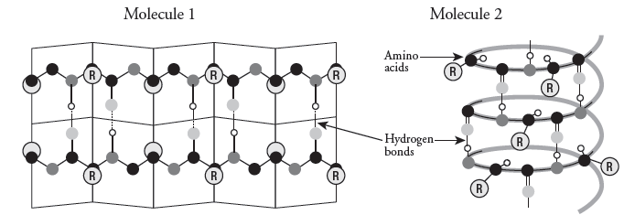
15. With your group, write a grammatically correct sentence that summarizes how the secondary protein structure is formed from the primary structure.

Model 3 – Protein Structure (Part B)
Tertiary Structure Quaternary Structure

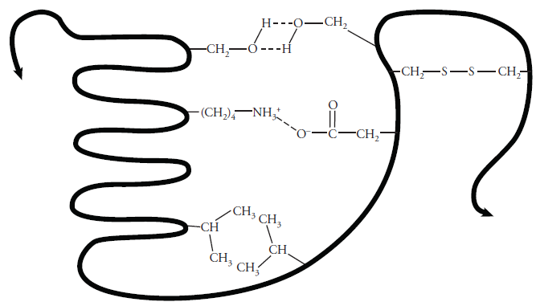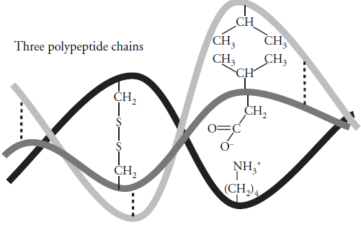

16. Examine the tertiary structure in Model 3 and note the interactions that hold this level of structure in place.
a. Four types of bonds or interactions are shown. Label them with the following terms.
Disulfide bridge Hydrogen bond Hydrophobic interactions Ionic bond

b. Describe the part of the amino acid that participates in these interactions.

c. How does your answer in part b differ from the bonds that stabilize the secondary structure?

17. What type of functional groups or atoms would need to be present in the R-groups for hydrogen bonding to occur between two amino acids in a protein chain?

18. What type of functional groups or atoms would need to be present in the R-groups for hydrophobic interactions to occur between two amino acids in a protein chain?

19. How many polypeptide chains are shown in the tertiary protein structure in Model 3?

20. Many proteins, but not all, have a fourth level of structure termed quaternary structure.
a. How many polypeptide chains are shown in the quaternary structure of the protein in Model 3?

b. What types of bonds and interactions hold the quaternary structure in place?

21. With your group, using grammatically correct sentences, define the following.
a. Tertiary protein structure.

b. Quaternary protein structure.

22. Imagine a protein chain that includes the following amino acids among several others.
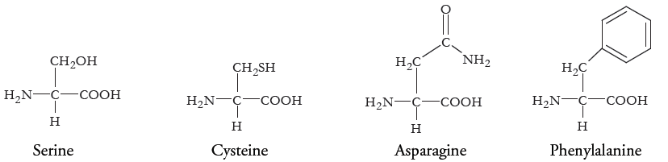
a. Which of the amino acids could form a hydrogen bond with another amino acid in the chain to stabilize the secondary structure of a β-pleated sheet?

b. Which of the amino acids could form disulfide bonds with another amino acid in the chain to stabilize the tertiary structure of the protein?

c. Which of the amino acids could participate in hydrophobic interactions with another amino acid in the chain to stabilize the tertiary structure of the protein?

d. What types of bonds or interactions could asparagine form with another amino acid in the chain in order to form a quaternary structure with another protein chain?

23. Fill in the following chart using what you’ve learned from Models 1–3.
Structure | Bond(s) or interactions holding the structure together | Short description | Number of polypeptide chains involved
Primary |  |  | 1
Secondary |  |  | 1
Tertiary |  |  | 1
Quaternary |  |  | 2 or more
Read This!
Heating and changing pH levels are two ways to disrupt the shape of a protein. High temperatures or pH levels that vary from the natural environment of the protein will break hydrogen bonds, ionic bonds, disulfide bridges, and hydrophobic interactions. Covalent bonds will usually remain undisturbed. This process of destroying the shape of a protein is called denaturing.
24. Which of the four levels of protein structure is maintained after denaturing? Explain your answer.

25. Proteins carry out a variety of functions, and their function is critically dependent upon their structure and shape. Enzymes are proteins. What would happen to the structure and function of an enzyme that was exposed to heat or a drastic change in pH?

26. When people get their hair chemically straightened, one chemical is put on the hair to break the disulfide bonds that give the hair strands their shape (curled) and a second chemical is used to reform the disulfide bonds to hold the hair in a new position (straight).
a. What level(s) of protein structure is/are affected by these processes?

b. Why doesn’t the hair stay straight forever after this treatment?

Extension Questions
27. If a mutation in the DNA of an organism results in the replacement of an amino acid containing a polar R-group with another amino acid containing a nonpolar R-group, how might the structure of the protein be affected? Address the impact on all levels of the protein structure in your answer.
28. Egg whites are primarily composed of the protein albumin. One familiar example of the denaturing of proteins is the difference between the albumin structure in a raw egg versus a cooked egg. Using what you know about the levels of structure in proteins, propose an explanation of changes in albumin (and other proteins) that occur during cooking.
29. Predict what would happen to the egg white if a raw egg were placed in vinegar. Explain your thinking.

